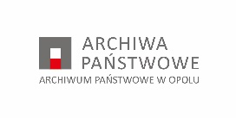

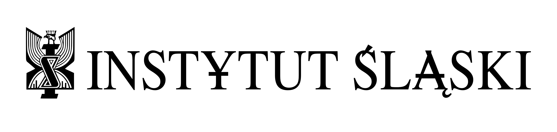

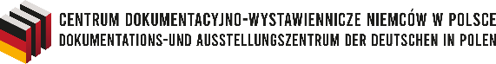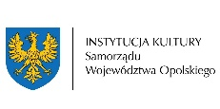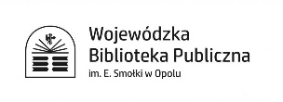

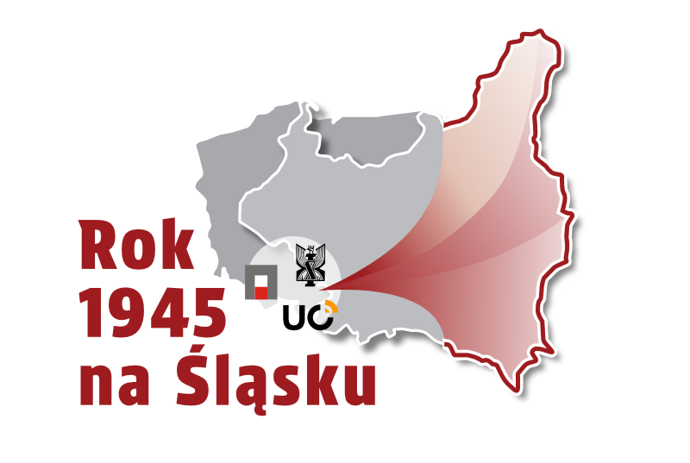

**INTERNATIONAL ACADEMIC CONFERENCE  
"THE YEAR 1945 IN SILESIA"  
Opole, 9–10 October 2025**

**REGISTRATION FORM  
Participation in the conference with a paper**

**Submission deadline: 29 August 2025  
Please send your application to: j.siek@instytutslaski.pl**

**Full name: …………………………………………………………  
E-mail: ………………………………………………………………  
Phone number: ……………………………………………………  
Affiliation: ………………………………………………………….**

**Proposed paper title:**

………………………………………………………………………………….

………………………………………………………………………………….

………………………………………………………………………………….

**Abstract of the presentation *(max. 500 characters including spaces)*:**

…………………………………………………………………………………………………………………………….

…………………………………………………………………………………………………………………………….

|  |  |
| --- | --- |
|  | **Plenary Session** |
|  | **Student/Doctoral Student Session + Early Career Researchers** |

(please mark the appropriate boxes below by inserting an “X”)

**(please mark the appropriate boxes below by inserting an “X”)**

**☐ Consent**

I hereby give my consent for the processing of my personal data included in the registration form as well as personal data recorded during the course of the conference (photographs, audio-video recordings), by Instytut Śląski (the Silesian Institute) with its registered office in Opole (hereinafter referred to as the “Administrator”), address: ul. Piastowska 17, 45–082 Opole, e-mail: sekretariat@instytutslaski.pl, phone: +48 77 453 60 32 or +48 534 287 885, for the purpose of organizing the conference entitled International Academic Conference "The Year 1945 in Silesia" (hereinafter referred to as the “conference”), and for the purpose of a post-conference publication.

See: Information Clause

**☐ Additional Declaration (image rights)**

I hereby give my consent for the dissemination by Instytut Śląski (the Silesian Institute) with its registered office in Opole of my image, recorded in the form of photographs and audio-video recordings during the conference, through the publication of such materials on the website of Instytut Śląski (the Silesian Institute) and the websites of the conference co-organizers, namely: Archiwum Państwowe w Opolu (the State Archives in Opole), Instytut Historii Uniwersytetu Opolskiego (the Institute of History of the University of Opole), Wojewódzka Biblioteka Publiczna im. Emanuela Smołki w Opolu (the Emanuel Smołka Voivodeship Public Library in Opole), Centrum Dokumentacyjno-Wystawiennicze Niemców w Polsce (the Documentation and Exhibition Centre of Germans in Poland), as well as on the social media channels of Instytut Śląski (the Silesian Institute) and the above-mentioned co-organizers.

**☐ Additional Declaration (post-conference publication)**

I undertake to submit to Instytut Śląski (the Silesian Institute) with its registered office in Opole a print-ready version of the paper presented during the conference no later than 31 December 2025, by sending it to: j.siek@instytutslaski.pl.

Upon submission of the paper, I grant Instytut Śląski (the Silesian Institute) a non-exclusive, perpetual and territorially unlimited license to use the paper on the following fields of exploitation:

a) permanent or temporary reproduction of the paper, in whole or in part, by any means and in any form, including recording and reproduction by any technique, such as magnetic recording or digital technology, including CD, DVD, Blu-ray, flash memory devices, or any other data storage medium;

b) translation, authorized modifications of the layout, or making any other alterations to the paper;

c) dissemination of the paper by making it publicly available in such a way that any person may access it at a place and time of their own choosing.

**INFORMATION:**

(based on Section 13 of Regulation (EU) 2016/679 of the European Parliament and of the

Council of the European Union of 27 April 2016 on the protection of natural persons with

regard to the processing of personal data and on the free movement of such data

and on repealing Directive 95/46/EC (General Data Protection Regulation, hereinafter

referred to as the Regulation))

1. The Administrator of your personal data is the Silesian Institute, with its registered office

in Opole, ul. Piastowska 17, 45-082 Opole, NIP: 7543234042, REGON: 384024788.

2. The Administrator's representative is ……………………… (name, registered office

address, NIP, REGON).

3. The Data Protection Officer appointed by the Administrator is: Andrzej Gawłowski,

contact at e-mail address iod@instytutslaski.pl or the administrator's address indicated

in Paragraph 1.

4. The processing of personal data is carried out in particular in order to fulfill the legal

obligation of the Administrator towards persons sending correspondence or using other

forms of contact with the Institute. This obligation results from the duties of the

administration imposed by law, concerning handling matters within competence of the

Director of the Silesian Institute. It is also possible to process personal data for other

purposes, but only in accordance with the principles specified in Section 5 of the Regulation

and on the basis of Section 6 of the Regulation.

5. Personal data will be transferred to the following recipients or categories: only to entities

authorized or competent to respond to the correspondence sent on the basis of legal

regulations and to entities entrusted with the processing of personal data on the basis

of a concluded agreement entrusting the processing of such data.

6. Your personal data will not be/will be* transferred to third countries or international

organizations.

7. Information regarding your personal data will be available at the following address:

Silesian Institute, ul. Piastowska 17, 45-082 Opole (sekretariat@instytutslaski.pl)

or the e-mail address of the Data Protection Officer.

8. Your personal data will be processed:

a) for the purpose of concluding and implementing a contract - pursuant to Section 6

sec. 1 Subparagraph b) Regulation (EU) 2016/679 of the European Parliament and of the

Council of 27 April 2016 on the protection of natural persons with regard to the

processing of personal data and on the free movement of such data, and repealing

Directive 95/46/EC (General Data Protection Regulation) (hereinafter referred to as:

Regulation (EU) 2016/679), and to the extent that the provision of data is optional, as

well as for marketing purposes – based on your consent (Section 6 Subsection 1

Subparagraph a of Regulation (EU) 2016/679),

b) for the purposes of fulfilling the legal obligations incumbent on the

Administrator resulting from generally applicable provisions of law – based on Section

6 Subsection 1 letter a of c) Regulation 2016/679,

c) in order to implement the legitimate interest of the Administrator consisting

in particular in possible determination or pursuit of claims or defense against claims

- based on Section 6 section 1 letter f of Regulation 2016/679.

9. You have the right to:

− request the Administrator to access the content of your personal data,

− request the Administrator to rectify the content of your personal data,

− request the Administrator to delete or limit the processing of your personal data,

− transfer your personal data,

− withdraw consent to the processing of your personal data at any time, without affecting

the lawfulness of the processing of personal data, which was carried out on the basis

of consent before its withdrawal,

− object to the processing of your personal data (for evidentiary purposes, the objection

should be filed in writing or electronically).

10. You have the right to lodge a complaint with the supervisory authority if you consider that the processing of your personal data violates the law.

11. Your personal data will be processed:

a) until you withdraw your consent - in the event that personal data are processed

on the basis of your consent,

b) for the duration of the contract - in the event that the processing of personal data

is necessary to perform the contract,

c) for the duration of the legal obligation - in the event that the processing of personal

data is necessary to fulfill the legal obligation of the Administrator,

d) for the duration of the legally justified interests pursued by the Administrator

- in the event that the processing of personal data is necessary for the purposes resulting

from legally justified interests pursued by the Administrator.

12. Your personal data will not be / will be* processed in an automated manner and in the form of profiling.

13. Providing your personal data is voluntary; however, failure to consent to the processing

of your personal data may result in the impossibility of providing services to you (it will

prevent the conclusion and execution of a contract).

In matters pertaining to the processing of personal data, you may contact the Data Protection Officer by e-mail at iod@instytutslaski.pl or in writing at the address indicated in point 1 above.

Your image shall be processed for the purposes of documenting and disseminating information regarding the activities undertaken by the Management and employees of Instytut Śląski (the Silesian Institute), pursuant to Article 6(1)(c) of Regulation (EU) 2016/679 of the European Parliament and of the Council of 27 April 2016 (General Data Protection Regulation – GDPR), concerning the protection of natural persons with regard to the processing of personal data and on the free movement of such data, and repealing Directive 95/46/EC.

The recipients of your personal data may include any individuals who access photographic, video, or other audiovisual materials published on the Institute’s official website and/or social media platforms.

Participation in events, and thereby the provision of personal data in the form of your image, is entirely voluntary; however, it is a necessary condition for participation in said events.

Your personal data shall not be subject to automated decision-making, including profiling, and shall not be transferred to third countries or international organisations.

Where the data subject’s image does not constitute a minor detail of a larger whole - such as a public or outdoor event, assembly, or landscape - each data subject shall have the right to withdraw consent to the processing of their image. Withdrawal of consent shall not affect the lawfulness of processing based on consent before its withdrawal.

Data subjects shall have the right to access their personal data, to rectify or erase such data, to restrict its processing, and to data portability, in accordance with applicable data protection legislation.

Data subjects shall also have the right to object to the processing of their personal data on grounds relating to their particular situation.

You have the right to lodge a complaint with the President of the Personal Data Protection Office (Prezes Urzędu Ochrony Danych Osobowych) if you believe that the processing of your personal violates applicable data protection laws.

Should you not wish for your image to be recorded and disseminated, you are kindly requested to inform the Secretariat using the contact details provided in point 1 above.

Data: ………………………. Podpis: …………………………………………………